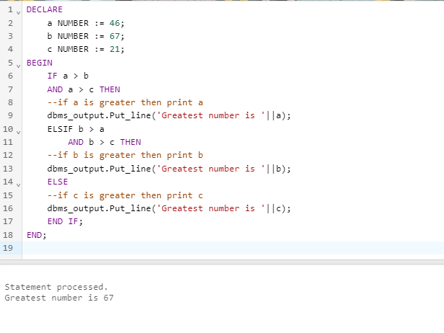Q1- Write a PL/SQL code to accept the value of A, B & C display which is greater.

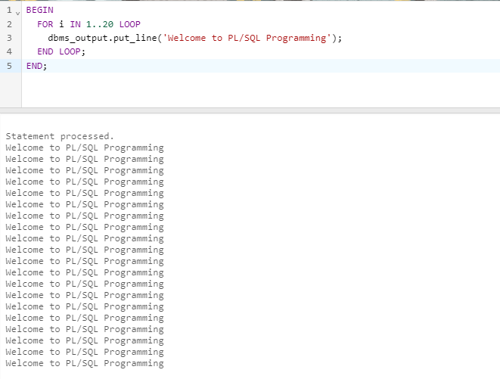Q2- Using PL/SQL Statements create a simple loop that display message “Welcome to PL/SQLProgramming” 20 times?

Q3- Write a PL/SQL code block to find the factorial of a number.

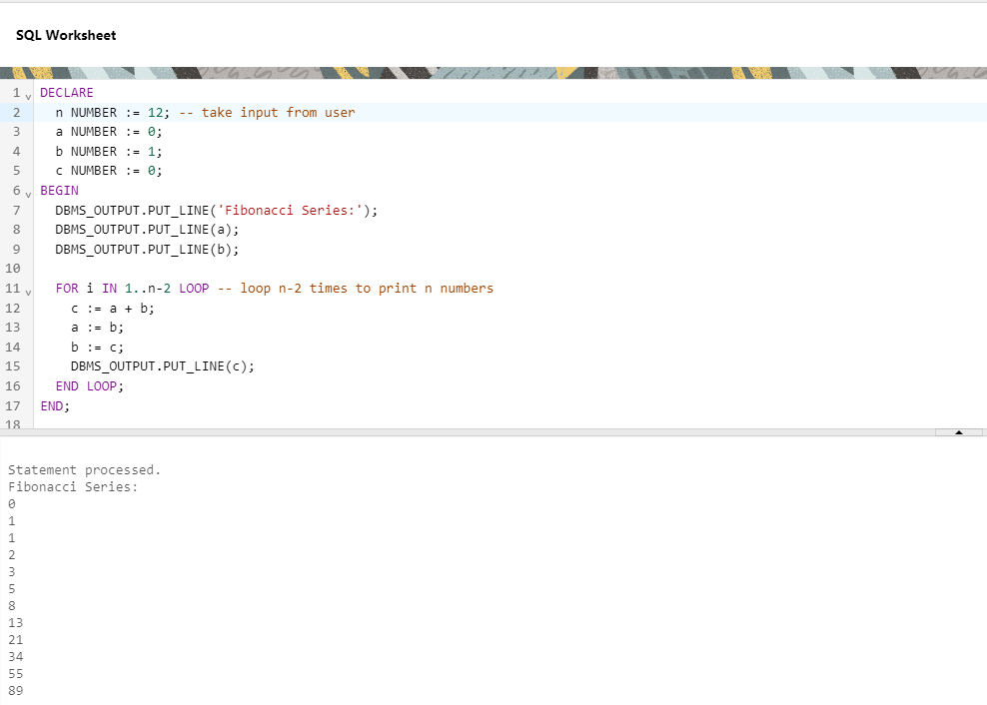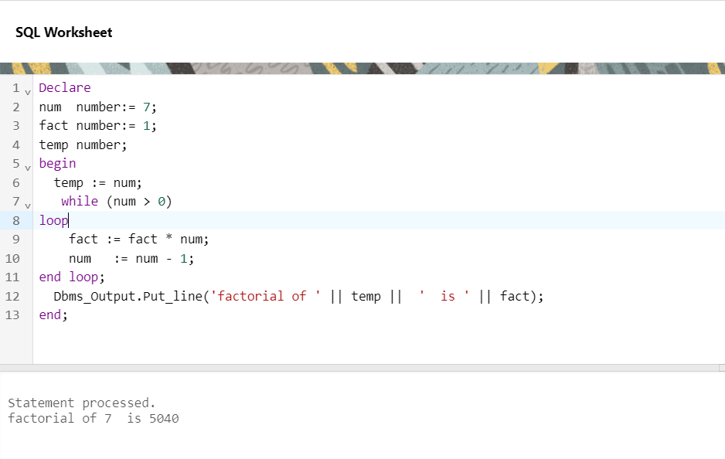Q4- Write a PL/SQL program to generate Fibonacci series

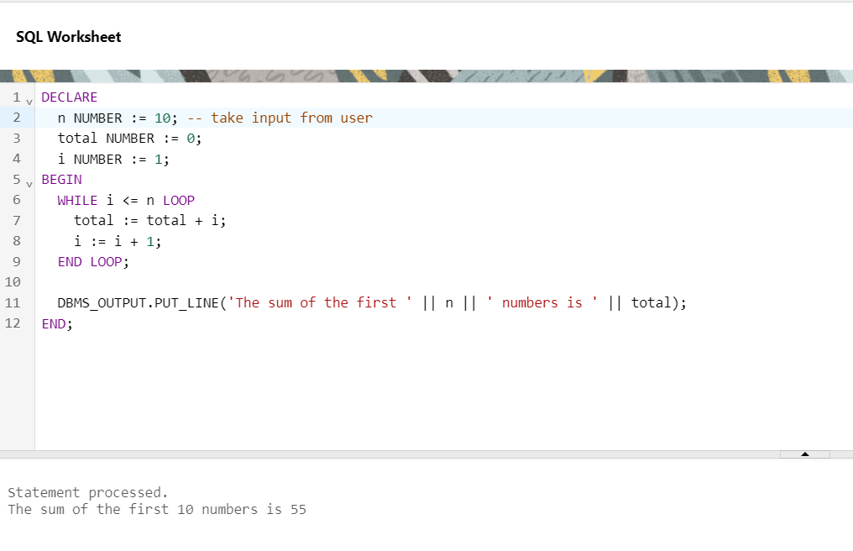Q5- Write a PL/SQL code to fund the sum of first N numbers